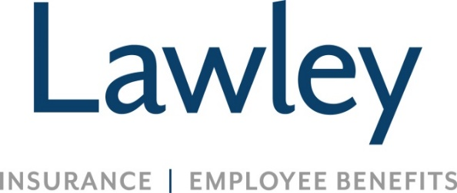
Commercial Insurance Account Associate
These are the fundamental components of the job:
- Support the Commercial Lines service and/or marketing team with processing of documents, internal requests, data entry, and preparation and entry of marketing submissions to carrier or marketing department
- Preparing policies for delivery/distribution
- Accurately input and maintain compliance, client and vendor data (MVR’s, loss runs, other external sourced data)
- Distribution of internal reports; compilation of internal compliance/ quality assurance audits
Other functions of the job:
- Provide administrative support, including electronic mail, documents, spreadsheets and presentations
- Embrace all training opportunities to learn the insurance business
- Expand and grow in your role when supporting miscellaneous duties as requested
Skills / traits that we value for this role:
- At least one-year experience in an office setting
- Interest in acquiring knowledge of insurance products; Insurance documents and usages are a plus
- MS Word, Excel, and PowerPoint proficiency are a must!
- High School diploma required
- Ability to work well independently and on a team

- Incredible attention to detail, organizational skills, and strong time management capabilities
- Open to continuing education, including but not limited to a P&C licensing course
- Positive attitude, even in a fast-paced environment
- A passion to make customers and coworkers feel important and valued
- Precise communication skills, even under time constraints
- A desire to pursue a career in the insurance industry
A bit about Lawley!
- We are not a call center environment
- We achieve success by building genuine relationships together, with our teams and clients
- We are a family owned insurance broker (70+ years!)
- We are deeply committed to the communities we serve and love to get involved
- We work hard and play hard!!!
Why Lawley?
- Competitive salary and referral bonuses!
- Expansive Benefits (Medical, Dental, Vision—and SO many more)
- 3 weeks of PTO (prorated based on start date) AND a generous holiday schedule – available 1st day!
- Company 401K contribution received starting Day 1 (for participants 21+ years old)
- Educational support, career development, and growth opportunities
- Job Security (we’ve never had a lay-off, even during the pandemic)
- Flexibility, including hybrid schedules! Business hours 8am-4:30pm
- Comfortable, family-oriented culture, with an emphasis on work life balance
- Unlimited Volunteer Time Off opportunities (so you can assist in serving our communities)
- Fulfilling opportunities that align with your career path and our business needs

The compensation range for this position takes many factors into consideration including but not limited to: years of experience/training, skill set, and licenses/designations. It is not typical for an individual to be hired near the top of the range for a position as circumstances and location can vary in every hiring situation. A reasonable estimate of the current range is $33,000 to $55,000.

