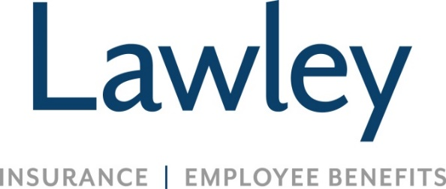

Personal Insurance Account Manager
These are the fundamental components of the job:
- Manage an assigned book of existing business, focusing on growth and retention. The Account Manager will routinely conduct consultative conversations with our clients and prospects to ensure all coverage needs are addressed
- Develop, quote and sell Personal Insurance to new and existing clients
- Work within designated timelines to provide superior customer service to retain our clients, as well as referrals and new business opportunities
- Responsibilities for processing endorsements and creating insurance documents as needed
Other functions of the job:
- Establish and maintain professional relationships with carriers and clients
- Expand and grow in your role when supporting miscellaneous duties as requested
Skills / traits that we value for this role:
- Insurance experience in customer service or account management for 3 years or more
- Property/Casualty License
- Relevant knowledge of insurance products, documents and usages
- Computers skills are a must, Applied & EPIC experiences is preferred
- Ability to work well independently and on a team
- Incredible attention to detail and organizational skills

- Open to continuing education, college degree preferred
- Positive attitude, even in a fast paced environment
- A passion to make customers and coworkers feel important and valued
- Capability to work quickly and efficiently
- Methodical, yet swift decision making skills
- Precise verbal and written communication skills, even under time constraints

A bit about Lawley!
- We are not a call center environment
- We achieve success by building genuine relationships together, with our teams and clients
- We are a family owned insurance broker (70+ years!)
- We are deeply committed to the communities we serve and love to get involved
- We work hard and play hard!!!
Why Lawley?
- Competitive salary and referral bonuses!
- Expansive Benefits (Medical, Dental, Vision—and SO many more)
- 3 weeks of PTO (prorated based on start date) AND a generous holiday schedule – available 1st day!
- Company 401K contribution received starting Day 1 (for participants 21+ years old)
- Educational support, career development, and growth opportunities
- Job Security (we’ve never had a lay-off, even during the pandemic)
- Flexibility, including hybrid schedules! Business hours 8am-4:30pm
- Comfortable, family-oriented culture, with an emphasis on work life balance
- Unlimited Volunteer Time Off opportunities (so you can assist in serving our communities)
- Fulfilling opportunities that align with your career path and our business needs

The compensation range for this position takes many factors into consideration including but not limited to: years of experience/training, skill set, and licenses/designations. It is not typical for an individual to be hired near the top of the range for a position as circumstances and location can vary in every hiring situation. A reasonable estimate of the current range is $51,498.15 to $85,830.25.

